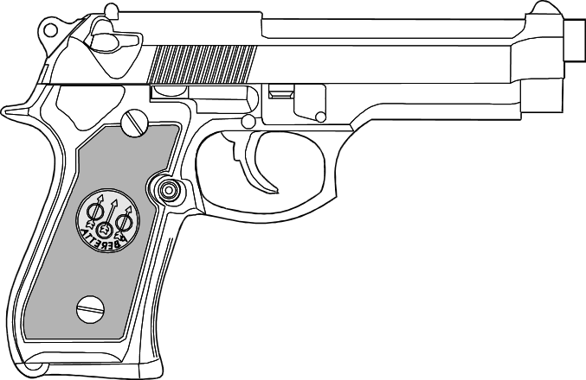
Interested in learning to shoot a handgun?

The Golden Valley County Sheriff’s Office is sponsoring an Introductory Handgun course, open to the public:
Friday, September 29, 2017, from 5:00 PM to 9:00 PM
Saturday, September 30, 2017, from 8:00 AM to 12:00 PM
Designed for the beginner, this course will include both classroom and hands-on (shooting) instruction. Women are encouraged to attend, but any responsible adult 18 years of age or older is welcome; no prior experience with a handgun is required! The instructor for this course will be Phil Pfennig of Freedom and Valor Firearms and Training of Mandan, ND. This presents a unique opportunity to learn new skills as they apply to defensive handgun or recreational shooting use.
To register, please stop at the Golden Valley County Sheriff’s Office in the basement of the courthouse in Beach. The fee for the course is $100; a $50 deposit must be paid when registering, prior to the course (non-refundable unless weather-related cancellation) with the remainder due on the day of the course. There is a maximum class size of 12 to allow for personal attention and instruction, so don’t delay!
Attendees must bring their own handgun, approximately 400 rounds of quality ammunition, and protective equipment (list available upon registration).
For more information, contact Deputy Dion Steinley at the Sheriff’s Office, (701)872-4733.

North Dakota Class 1 Concealed Weapons Permit Course

The Golden Valley County Sheriff’s Office is sponsoring a Class 1 Concealed Weapons permit course, open to the public:
Saturday, September 30, 2017, from 11:00 AM to 8:00 PM
This course will satisfy the regulations as mandated by the ND Attorney General’s Office for completion of Class 1 concealed weapons permit testing. This course includes a class (lecture), a written exam, and a proficiency (shooting) exam. This course is not for the beginner, as proficiency testing incorporates safely handling and shooting a handgun, as well as drawing and reloading a handgun. Attendees must provide their own handgun, holster, ear and eye protection, and ammunition (list provided when registering). For State-mandated regulations, visit: http://www.ag.nd.gov/BCI/CW/CW.htm
To register, please stop at the Golden Valley County Sheriff’s Office in the basement of the courthouse in Beach. The fee for the course is $50 (non-refundable unless weather-related cancellation), which must be paid when registering, prior to the course. There is a maximum class size of 20, so don’t delay! Fingerprinting and photo for the completion of the application will be available during the course. For more information, contact Deputy Dion Steinley at the Sheriff’s Office, (701)872-4733.

